PSSI Science Project Reporting Template

️ | The PSSI Implementation Team is compiling a technical report to demonstrate the important research and advancements made by the Science Branch through the PSSI funding. The technical report will include a 3-4 page summary (including graphics and figures) for each project to show their key results and findings. Please fill in the following fields and sections for your project to be included in the report. Feel free to include and draw from any reports or presentations previously created through your research.  A plain language science bulletin will also be created to follow up on last year’s “DFO Pacific Region Science Bulletin, 2024. New research and monitoring for Pacific salmon and their ecosystems.” While the first bulletin introduced project backgrounds, methods, and timelines, this new bulletin will highlight the projects’ results, key findings, and conclusions with links to reports and data available. The bulletin will include a 1-2 page summary for each project gleaned from the content entered below.  ️ Completed forms are due January 7, 2026.  *Please include or send separately any graphics or pictures (with photo credits) that will help promote the projects.

PART 1: PROJECT METADATA

General Project Information
Project ID (number) | Project Title
2433 | Integrated Salish Sea acoustic monitoring of salmon and salmon prey
Project Leads | Collaborations and External Partners
Stéphane Gauthier | Akash Sastri, Kelly Young, Jennifer Boldt, Chris Rooper, Doug Bertram
Location (if applicable)
Salish Sea

Geographic and Stock Information
Salmon species (if applicable) | Waterbodies (if applicable)
Click or tap here to enter text. | Click or tap here to enter text.
Life history phases (if applicable) | Region
juvenile | Salish Sea
Stock (if applicable) | Population (if applicable)
Click or tap here to enter text. | Click or tap here to enter text.
Conservation Unit (if applicable)
Click or tap here to enter text.

🧰 PART 2: PROJECT METRICS

Project Outputs
Include any anticipated outputs denoted as (in progress). Please include links to any outputs available online so they can be referenced in the report.
List scientific publications and technical reports (with links)
Click or tap here to enter text.
List datasets generated (with links)
Active Acoustic Data
Describe dataset locations and data management systems
Active Acoustic Data archived at the Institute of Ocean Sciences, following National Acoustic Data Archive protocols and ICES metadata standards.
List code, programs, or other software created (with links)
Click or tap here to enter text.
List communication or social media products
Pacific Herring seasonal use of nearshore habitat assessed by moored acoustics and stereo-optics– presentation at the ICES Working Group on Fisheries Acoustics, Science and Technology, April 2024, Brest, France

Fisheries Acoustics for salmon science – presentation at the Institute of Ocean Sciences open-house, June 2024.

Fisheries Acoustics as a tool to monitor Salmon, Salmon prey, and Salmon predation – presentation to the Maa-nulth JFC, January 2026.

List and describe field work completed
Deployments and retrievals of 3 autonomous echosounder moorings within the Salish Sea
List and describe samples collected/analyzed (number of samples)
Over 30,000 hours of continuous data recording from autonomous echosounders
List and describe large capital assets or equipment acquired
Click or tap here to enter text.

PART 3: WRITTEN CONTENT

Highlights
Please summarize in 2-3 bullets:
- The main idea of the project
- Key findings
- Implications of these findings for salmon and decision-makers
- For a more technical audience, but still as plain language as possible
- Large scale acoustic surveys within the Salish Sea indicate the presence of Pacific hake (a significant source of potential predation for juvenile salmon) throughout the Salish Sea, with increasing biomass over the past years.
- Fine temporal scale monitoring in nearshore coastal areas of the Strait indicate low abundance of juvenile salmon compare to juvenile Pacific herring, suggesting high levels of competition for food.
- The nearshore moorings (including cameras) revealed a wide array of potential predators for juvenile salmon, but surface predation from birds and/or marine mammals were not as frequent as observed in nearshore coastal areas of Barkley Sound.
- Deeper mooring in the central Strait of Gorgia revealed that Pacific hake (predators) were present almost year-round.

Background
Please provide 1-2 paragraphs to summarize
- The relevant biological, environmental, and/or management context
- What knowledge gap or demand were you trying to fill?
- Collaboration and partner relationships
Fisheries acoustics can be used to answer a number of questions related to Salmon ecology and dynamics. On large spatial scales, acoustic surveys are used to assess salmon prey (e.g forage fish and krill) conditions within the Salish Sea, identify prey hotspots, key predators of juvenile salmon, and assess changes in productivity through time. On a finer temporal scale, moored autonomous echosounders can provide information on juvenile salmon coastal habitat use, in conjunction with prey availability and predation pressures.

Autonomous echosounder system were used to address key elements affecting juvenile salmon during the first stage of marine life, including juvenile salmon use of coastal areas (time spent in key areas and within the water column), the prey conditions (e.g. euphausiids dynamic) they encounter in the Salish Sea, and the competition and predation pressures that affect them.

️ Methods and Findings
Please insert a few paragraphs to summarize:
- Main methods used
- Products and tools produced
- Advancements in methodology, technology, and application
- Advancements in communication and knowledge transfer
- Key results and information generated
We used active acoustics methods as a remote sensing tools to assess the salmonsphere (salmon as well as their prey and predators). Large scale fisheries acoustic surveys conducted within the Salish Sea are used to assess marine conditions and the abundance and distribution of key prey species and predators for salmon. On a finer temporal scale, we used moored inverted echosounders to monitor juvenile salmons (and salmonsphere ecosystem components) in nearshore habitats and within the larger Strait of Georgia basin.

This project used the same methods as described for project 2432. More specifically, two autonmous echosounders were moored on the bottom near Departure Bay and French Creek as part of a separate project focused on Pacific herring in 2022-2023. These data were re-analyzed to identify juvenile salmon and associated species. Another mooring was deployed in 2024 in the middle of the Strait of Georgia to assess ecosystem conditions in the deeper larger basin, to provide insight on the dynamic of key salmon prey species (euphausiids) and piscivorous predators (e.g. Pacific hake). Another echosounder mooring was deployed in Malaspina Strait in 2025 (but these data are not available yet).

Insights
Please insert a few paragraphs to summarize:
- What this project has added to knowledge about salmon populations, health, or ecosystems.
- How this project informs salmon management:
  - decisions
  - policy guidance
  - trade-offs
  - planning
- Addition of knowledge to understanding:
  - limiting factors/stressors/threats/ pathways of effects/risks
  - biologically significant thresholds
  - cumulative impacts
- Sources of uncertainty
- Large spatial scale acoustic data have revealed an increasing biomass of Pacific Hake throughout the Strait, with likely increased predation pressure for juvenile salmon, a sharp contrast to the West Coast, where Pacific hake biomass has drastically dropped over the past years.

- Moorings in nearshore coastal areas revealed the presence of juvenile salmon year-round, but in relatively low abundance. The nearshore habitat in the Salish Sea was largely dominated by Pacific herring (suggesting juvenile salmon are exposed to much higher competition for food).

- Potential predators of juvenile salmon were observed routinely on the moored acoustics as well as on regularly moored camera systems. Surface predation from birds and/or marine mammals were also observed, but far less frequently than on the West Coast (Barkley Sound).

- Moored autonomous echosounder in the central part of the Strait of Georgia further indicated that large predators (Pacific hake) were in the area for most of the year, and there was a strong seasonal signal of euphausiids and epi and mesopelagic communities in the Spring/Summer.

⏩ Next Steps
Please insert 1-2 paragraphs to summarize:
- Remaining knowledge gaps and recommendations for future studies
- How can/should the project findings be operationalized for salmon conservation and management?
This study was implemented in the second year of PSSI. Acoustic data collected from moored systems are only available once instruments are recovered, in as such, we are just finalizing the processing and analyses of acoustic data from moorings deployed in 2024 and 2025.

📈 Tables and Figures
Please provide captions and numbering for any tables and figures. Graphics can be copied below or e-mailed separately.
- Include a brief caption with each figure and table in the box below
- Number each table and figure, and include references in the above sections where appropriate.
- 1-3 figures are recommended per project
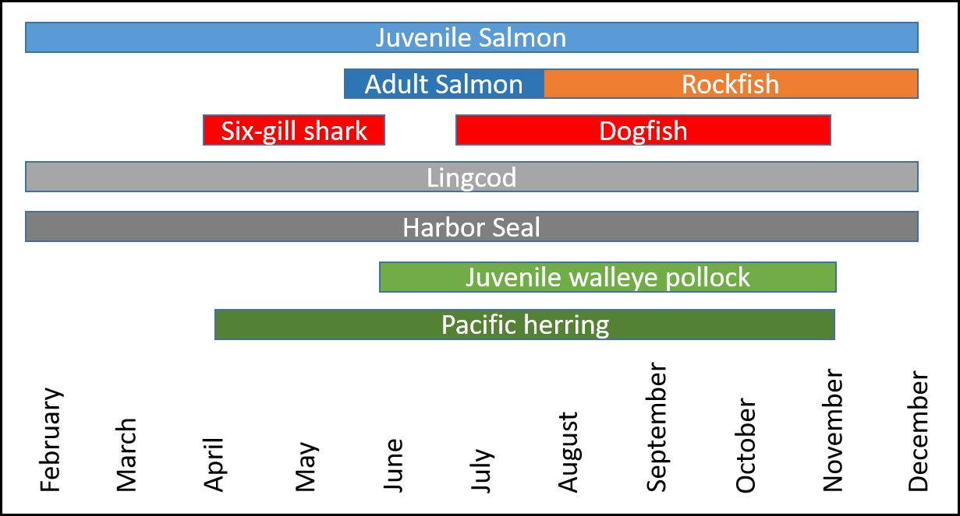
Figure 1. Seasonal dynamics of the Salish Sea nearshore environment as observed from continuous moored autonomous echosounder and regularly moored underwater cameras. Juvenile salmon where detected year-round at low densities (pale blue). The predators are listed in reddish and grey colors, while competitors are listed in green.

📈 References
Include full references for any publications referenced in other sections. Please format references in Harvard style according to Instructions to Authors for the Canadian Journal of Fisheries and Aquatic Sciences, at Canadian Science Publishing.
Click or tap here to enter text.

